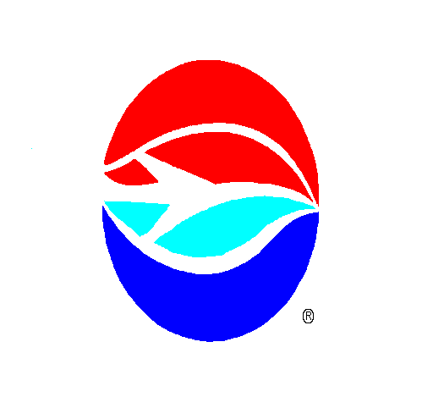
AVIATION AUTHORITY
PERMIT APPLICATION
Tampa International Airport Peter O. Knight Airport Plant City Airport Tampa Executive Airport
P.O. Box 22287, Tampa, FL 33622-2287
Scope/Nature of Request: (Provide summary of request, activities involved and any other required or pertinent information to fully describe scope, submit drawings and specification if needed. Additional pages may be used if necessary.)

LUXURY LIMOUSINES - PRE-RESERVED PASSENGER PICKUP AT TIA.

Request Date: _____________________ Airport: ______Tampa International Airport_________________
Permit Required Date From _________________________ to __September 30, ____________________
Applicant acknowledges receipt of the applicable procedures and/or provisions pertaining to the above request and agrees that, in consideration of issuance of this permit, applicant will be bound by the terms and conditions of the Ground Transportation Operating Procedures Manual and all other applicable State and Federal laws, Policies, Operating Directives, and Rules and Regulations. A copy of the Manual is provided with this permit application and can also be found on the Authority’s web site at www.tampaairport.com.
Name/Company/Organization: ______________________________________________________________________
Contact Person for Requested Activity: ________________________________________ Title: __________________
Mailing address: __________________________________________________________________________________
City: _______________________________ State: _______________________ Zip Code: ___________________
Phone No. _______________ Fax No. ____________________ E-mail Address: ____________________________
I hereby certify that the above statements are true and correct and I have full power and authority to act on behalf of the above named firm, corporation or organization in the submission of this application.

Printed Name of Authorized Representative: ___________________________________________________
Signature of Authorized Representative: __________________________________________ Date: ________________

All activities performed under this permit is at applicants own expense and risk, the Authority shall not be held liable for any damages, losses or injuries resulting from or connected with this activity.
This Section to be Completed By Aviation Authority Representative

Permission is hereby authorized for the requested activity.

Permit No. _____________________ Department: ______OPS/GT___________

_________________________________________________ ___________________________
Authority Representative Date

